Aim: The aim of this program is to convert a four digit hexadecimal number to decimal number.

Plan: I am going to design and write a program, that uses input boxes that ask the user for the hex number in stages, for example if the number to be converted was CA5D the first number to be convert would be C followed by A, and so on. The number will then be shown in a message box converted, (extra feature all the convert numbers will then be written to a file so it can be accessed at a later date. The file will have the hexadecimal number and its decimal conversion so for example would say “the hex value ca5d is 51805 in decimal”). Error checking the program will exit if a non hex value is entered, also the program WILL accept lower case a-f.

Testing: Testing will be conducted by myself. Testing will consist of entering a series of different values,
Test 1: Will have values that are within acceptable parameters 0-F and 0-f
Test 2: Will have valves that are out-with acceptable parameters for example G-Z or !”£$ %^&*()

Pseudocode:

Declare variables (i,i2,i3,i4 as strings x,x2,x3,x4,answer as integers)
user input for the first hex value (i4)
check if valid hexadecimal number
if value A-F of a-f convert to decimal
assign i4 to x4
x4= x4*4096

user input for the first hex value (i3)
check if valid hexadecimal number
if value A-F of a-f convert to decimal
assign i3 to x3
x3= x3*256

user input for the first hex value (i2)
check if valid hexadecimal number
if value A-F of a-f convert to decimal
assign i2 to x2
x2= x2*16

user input for the first hex value (I)
check if valid hexadecimal number
if value A-F of a-f convert to decimal
assign i to x

assign answer to x4+x3+x2+x

output answer to message box
write answer to Hex_Conversions.txt
display file written successful message box

Code:

package converter;

import java.io.*;
import javax.swing.*;

/**
*************************************
* *
* Version 1.3 *
* 20/10/15 *
* convert a hex number to a decimal *
* @author Steven Gibson *
* *
*************************************
*/

public class Converter {

public static void main(String[] args)
{
//Varible Declartion
//*************************
int x = 0; //*
int x2 = 0; //*
int x3 = 0; //*
int x4 = 0; //*
int answer; //*
//*
String Hex; //*
String i; //*
String i2; //*
String i3; //*
String i4; //*
//*************************

//makes an icon
final ImageIcon icon = new ImageIcon("icon.png");
final ImageIcon saved = new ImageIcon("saved.png");
//gets user in for hex number
Hex = (String) JOptionPane.showInputDialog(null, "Enter the whole hex number","Hex Converter",JOptionPane.PLAIN_MESSAGE,icon,null,null);

i4= Hex.substring(0,1);
//convert the hex number to a decimal number.
//uses stings so the letters a to f can be used in the input section an assigns them the variable x.

if (null != i4)
switch (i4)
{
case "0":
x4 = 0;
break;
case "1":
x4 = 1*4096;
break;
case "2":
x4 = 2*4096;
break;
case "3":
x4 = 3*4096;
break;
case "4":
x4 = 4*4096;
break;
case "5":
x4 = 5*4096;
break;
case "6":
x4 = 6*4096;
break;
case "7":
x4 = 7*4096;
break;
case "8":
x4 = 8*4096;
break;
case "9":
x4 = 9*4096;
break;
case "A":
case "a":
x4 = 10*4096;
break;
case "B":
case "b":
x4 = 11*4096;
break;
case "C":
case "c":
x4 = 12*4096;
break;
case "D":
case "d":
x4 = 13*4096;
break;
case "E":
case "e":
x4 = 14*4096;
break;
case "F":
case "f":
x4 = 15*4096;
break;
default:
JOptionPane.showMessageDialog(null,String.format("'"+i4 +"'" + " Is not a valid hex value "),"Hex conveter",JOptionPane.INFORMATION_MESSAGE, icon);
System.out.println(i4 + " Is not a vaild hex chacter");
System.exit(0);
break;
}
// System.out.println("the hex disgit so far " + i4 + " enter the second hex value");

i3= Hex.substring(1,2);
if (null != i3)
switch (i3)
{
case "0":
x3 = 0;
break;
case "1":
x3 = 1*256;
break;
case "2":
x3 = 2*256;
break;
case "3":
x3 = 3*256;
break;
case "4":
x3 = 4*256;
break;
case "5":
x3 = 5*256;
break;
case "6":
x3 = 6*256;
break;
case "7":
x3 = 7*256;
break;
case "8":
x3 = 8*256;
break;
case "9":
x3 = 9*256;
break;
case "A":
case "a":
x3 = 10*256;
break;
case "B":
case "b":
x3 = 11*256;
break;
case "C":
case "c":
x3 = 12*256;
break;
case "D":
case "d":
x3 = 13*256;
break;
case "E":
case "e":
x3 = 14*256;
break;
case "F":
case "f":
x3 = 15*256;
break;
default:
JOptionPane.showMessageDialog(null,String.format("'"+ i3+"'"+ " Is not a valid hex value "),"Hex conveter",JOptionPane.INFORMATION_MESSAGE, icon);
System.out.println("Not a vaild hex chacter");
System.exit(0);
break;
}
System.out.println("the hex digit so far " +i4+i3+ " Enter the third hex value");

i2= Hex.substring(2,3);
if (null != i2)
switch (i2)
{
case "0":
x2 = 0;
break;
case "1":
x2 = 1*16;
break;
case "2":
x2 = 2*16;
break;
case "3":
x2 = 3*16;
break;
case "4":
x2 = 4*16;
break;
case "5":
x2 = 5*16;
break;
case "6":
x2 = 6*16;
break;
case "7":
x2 = 7*16;
break;
case "8":
x2 = 8*16;
break;
case "9":
x2 = 9*16;
break;
case "A":
case "a":
x2 = 10*16;
break;
case "B":
case "b":
x2 = 11*16;
break;
case "C":
case "c":
x2 = 12*16;
break;
case "D":
case "d":
x2 = 13*16;
break;
case "E":
case "e":
x2 = 14*16;
break;
case "F":
case "f":
x2 = 15*16;
break;
default:
JOptionPane.showMessageDialog(null,String.format("'"+i2 + "' Is not a valid hex value "),"Hex conveter",JOptionPane.INFORMATION_MESSAGE, icon);
System.out.println("Not a vaild hex chacter");
System .exit(0);
break;
}

System.out.println("the hex digit so far " + i4+i3+i2 + " Enter last hex value");

i= Hex.substring(3,4);
if (null != i)
switch (i) {
case "0":
x=0;
break;
case "1":
x = 1;
break;
case "2":
x = 2;
break;
case "3":
x = 3;
break;
case "4":
x = 4;
break;
case "5":
x = 5;
break;
case "6":
x = 6;
break;
case "7":
x = 7;
break;
case "8":
x = 8;
break;
case "9":
x = 9;
break;
case "A":
case "a":
x = 10;
break;
case "B":
case "b":
x = 11;
break;
case "C":
case "c":
x = 12;
break;
case "D":
case "d":
x = 13;
break;
case "E":
case "e":
x = 14;
break;
case "F":
case "f":
x = 15;
break;

default:
JOptionPane.showMessageDialog(null,String.format("'"+ i + "' Is not a valid hex value "),"Hex conveter",JOptionPane.INFORMATION_MESSAGE, icon);
System.out.println("Not a vaild hex chacter");
System.exit(0);
break;
}
// calculates the number from the converted hex number
answer = x + x2 + x3 + x4;
System.out.println("the hex value " + i4 + i3 + i2 + i + " is " + (answer));
JOptionPane.showMessageDialog(null,String.format("the hex value "+ i4+i3+i2+i +" is "+answer),"Hex conveter",JOptionPane.INFORMATION_MESSAGE, icon);

// Writes the Hex number and it conversion to Decimal to a file called Hex_Conversion.txt

File myFile = new File("Hex_Conversions.txt");

try
{

FileWriter fw = new FileWriter(myFile,true);
BufferedWriter bw = new BufferedWriter(fw);
bw.write("the hex value "+ i4+i3+i2+i +" is "+answer + " in decimal");
bw.newLine();
bw.flush();
JOptionPane.showMessageDialog(null,String.format("File Saved"),"Hex conveter",JOptionPane.INFORMATION_MESSAGE, saved);
}

catch(IOException e)
{
System.out.println("An error has occured");
}
}
}

Testing Results:
Tests conducted 14/10/2015
Using Version 1.0

Test 1: Acceptable Values:

 | 1st Hex Value | 2nd Hex Value | 3rd Hex Value | 4th Hex Value | Expect Decimal Value | Actual Decimal Value
Test 1 | A | 2 | C | 4 | 41668 | 41668
Test 2 | 4 | c | 0 | F | 19471 | 19471
Test 3 | b | B | c | e | 48078 | 48078

Testing Evidence (Test 1):

 | 1st Hex Value | 2nd Hex Value | 3rd Hex Value | 4th Hex Value | Result
Test 1  (A2C4) | 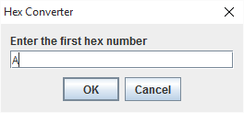 | 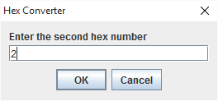 | 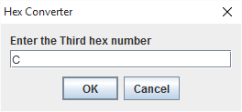 | 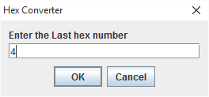 | 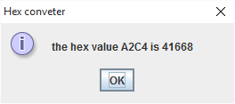
Test 2  (4c0F) | 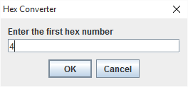 | 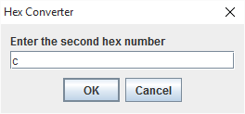 | 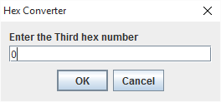 | 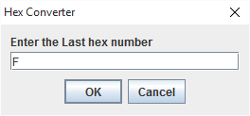 | 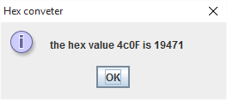
Test 3  (bBce) | 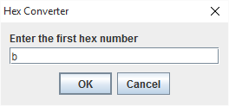 | 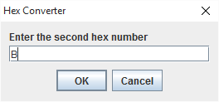 | 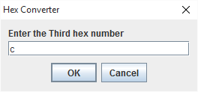 | 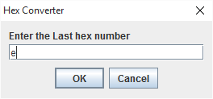 | 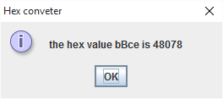

Hex_Conversion.txt screen-shot after 3 test were carried out:
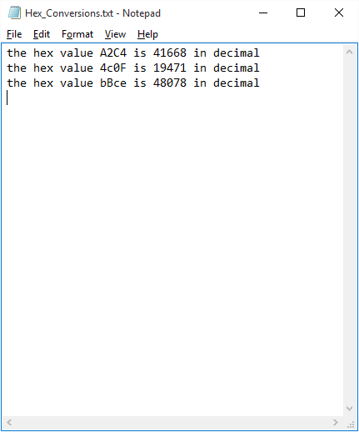

Test 2: Invalid Values:

 | 1st Hex Value | 2nd Hex Value | 3rd Hex Value | 4th Hex Value | Expect Result | Actual Result
Test 1 | ! | 2 | C | 4 | Error Message +  program exits after 1st value
Test 2 | A | T | C | 4 | Error Message +  program exits after 2nd value
Test 3 | a | 2 | . | 4 | Error Message +  program exits after 3rd value

Testing Evidence (Test 2):

 | 1st Hex Value | 2nd Hex Value | 3rd Hex Value | 4th Hex Value | Result
Test 1  (!2C4) | 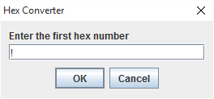 | No Image | No Image | No Image | 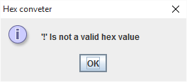
Test 2  (ATC4) | 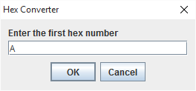 | 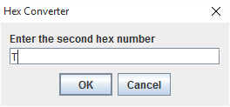 | No Image | No Image | 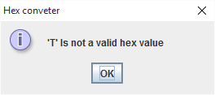
Test 3  (a2.4) | 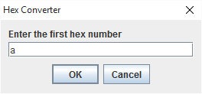 |  | 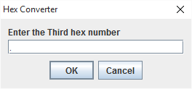 | No image | 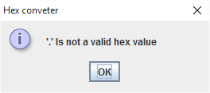

User Guide:
1. Introduction
2. Quick Start
2. Using the Program
3. FAQ
4.Version History

1. Introduction.

This program was designed to convert a 4 digit hexadecimal number to a decimal number. The results will be displayed on screen in a message box, The results will also be written to a file.

2.
Quick Start (Version 1.2).
Step 1
Start the program, you will see a message box to enter your first of your 4 hex digits. Enter the first one, so if your hex number is A2C4, Enter A. Press enter or press the OK button
Step 2
Enter the second hex digit, in our example it would be 2. Press enter or press the OK button.
Step 3
Enter the third hex digit, in Out example it would be C. Press enter or press the OK button.
Step 4
Enter the forth hex digit, in our example it would be 4. Press enter or OK button.
Step 5
A message box will display on the screen show you the converted number. It will also print it to
a file called Hex_Conversions.txt.
Step 6
The file (Hex_Conversion.txt) will be saved in the same folder that the program is stored

Quick Start (Version 1.3).

Step 1
Start the program, you will see a message box to enter your first of your 4 hex digits. Enter the first one, so if your hex number is A2C4, Enter A. Press enter or press the OK button

Step 2
Enter the second hex digit, in our example it would be 2. Press enter or press the OK button.

Step 3
Enter the third hex digit, in Out example it would be C. Press enter or press the OK button.

Step 4
Enter the forth hex digit, in our example it would be 4. Press enter or OK button.

Step 5
A message box will display on the screen show you the converted number. It will also print it to
a file called Hex_Conversions.txt.

Step 6
The file (Hex_Conversion.txt) will be saved in the same folder that the program is stored
3. Using the Program (Version 1.2)

Step 1
To extract “converter.zip” contents (with 7-zip installed), right-click the folder, click, 7-zip > Extract Here, and then follow the instructions.
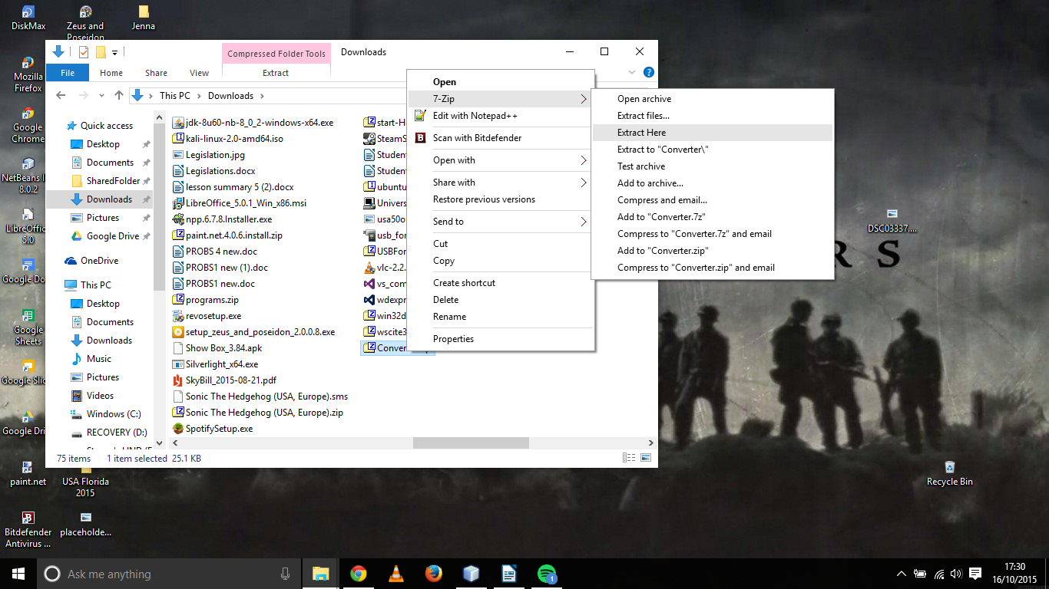

Step 2
open converter folder, then open Converter.jar

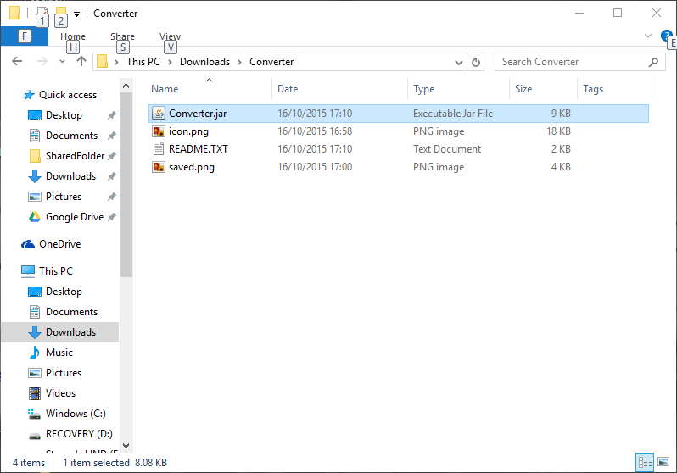

Step 3
Enter the first hex number so if the hexadecimal number is A2C4. Enter A in the text box, Then press Enter or press OK Button
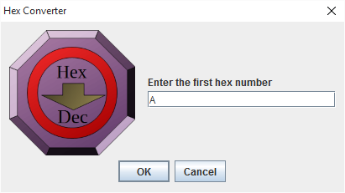

Step 4
Enter the second hex number so if the hexadecimal number is A1C4. Enter 1 in the text box, Then press Enter or press OK Button
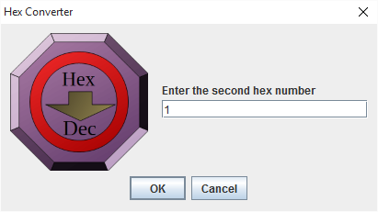

Step 5
Enter the third hex number so if the hexadecimal number is A1C4. Enter C in the text box, Then press Enter or press OK Button
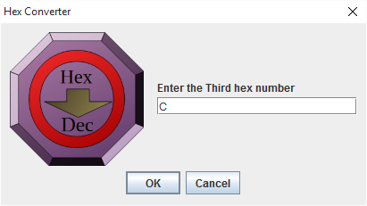

Step 6
Enter the third hex number so if the hexadecimal number is A1C4. Enter 4 in the text box, Then press Enter or press OK Button
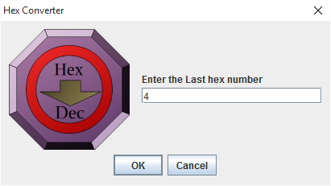

Step 7
a message box will appear on the screen giving the user the converted hex value. Press OK
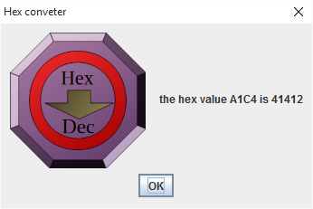

Step 8
A message box will appear confirming the file saved.
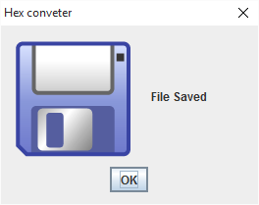

Step 9
To open the text document (Hex_Conversion.txt), Navigate to the folder where Converter.jar is stored the document will be stored there, double click to open the document.

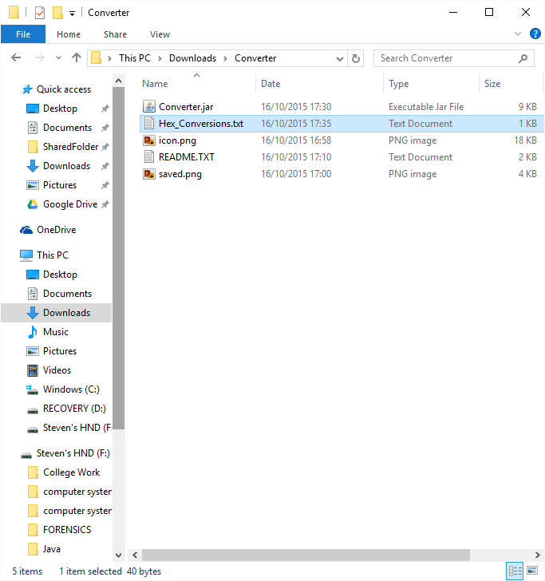

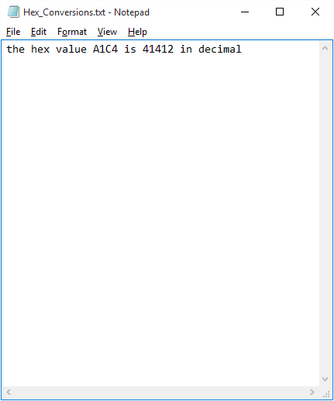
3. Using the Program (Version 1.3)

Step 1
To extract “converter.zip” contents (with 7-zip installed), right-click the folder, click, 7-zip > Extract Here, and then follow the instructions.

Step 2
open converter folder, then open Converter.jar

Step 3
Enter the hex number so if the hexadecimal number is A2C4. Enter the whole hex number so A2C4 in the text box, Then press Enter or press OK Button.
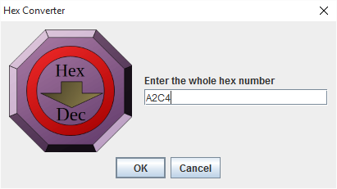

Step 3
a message box will appear on the screen giving the user the converted hex value. Press OK

Step 4
A message box will appear confirming the file saved.

Step 5
To open the text document (Hex_Conversion.txt), Navigate to the folder where Converter.jar is stored the document will be stored there, double click to open the document.

4. FAQ

Q: What happens if I enter a non-hexadecimal value?
A: If a non-hex value is entered the program will end and a message will be displayed that the value is invalid. You will see this screen
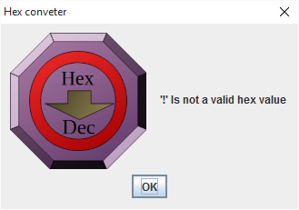

Q: Do I have to enter A-F in capital letters?
A: No the program will accept lower case A-F and convert them.

Q: Does the program convert from decimal to hexadecimal?
A: No not at this moment (Version 1.2), Decimal to hexadecimal will be added in an update.

Q: What files should be in the zip folder?
A: The files contained with the zip folder should “Converter.jar”, “icon.png”, ”saves.png”, “Readme.txt”

5. Version History

14/10/15
Version 1.0: Program built and testing conducted

14/10/15
Version 1.1: Bug fixes, added message box for the file being saved, file name fixed, spelling mistakes fixed.

16/10/15
Version 1.2: Icons added to all message boxes

20/10/15
Version 1.3: Changed program so the user now only enters the whole hex number

